**First program**

**package javaapplication1;**

**public class JavaApplication1 {**

**public static void main(String[] args) {**

**System.out.println("hello world");**

**}**

**}**

**Using variable**

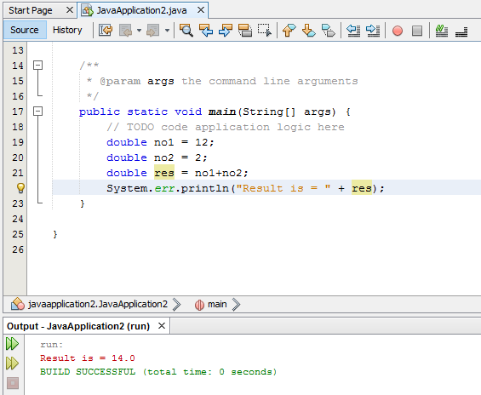

**.**

**Using operator**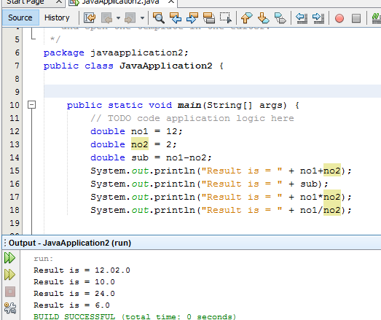

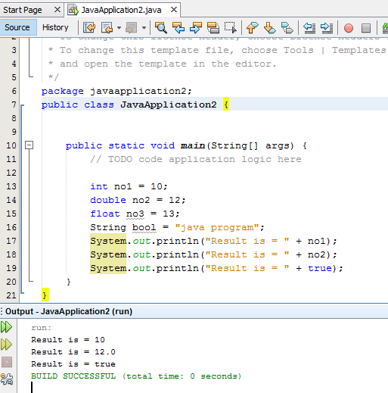

**Increment decrement** 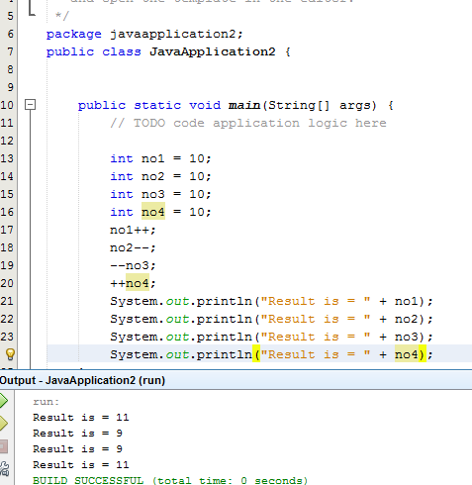

**Using logical operator**

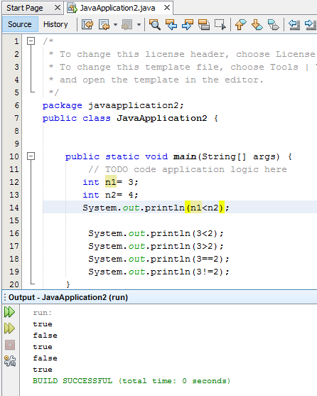

**If else**

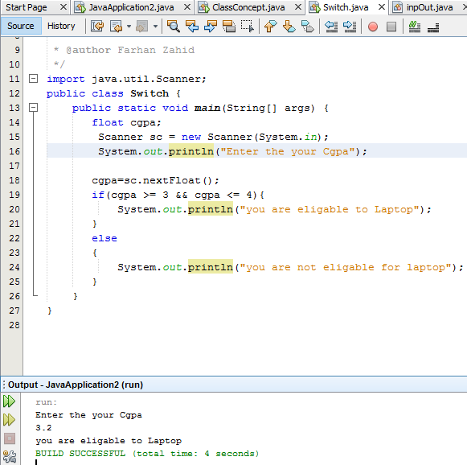

**Bool type**

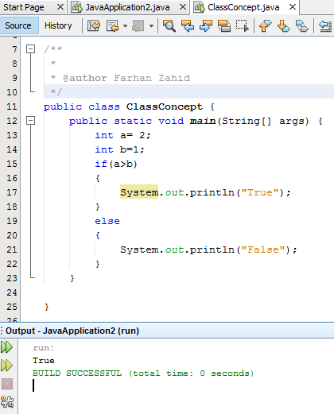

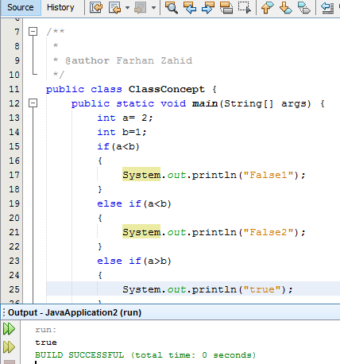

**Switch statement** 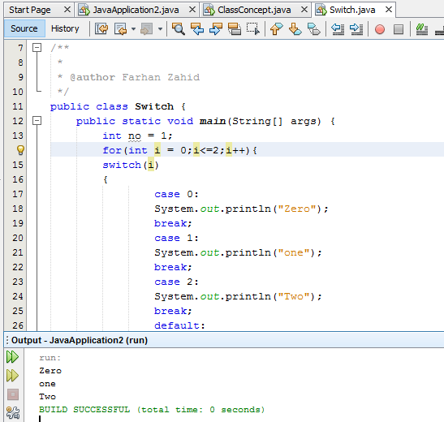

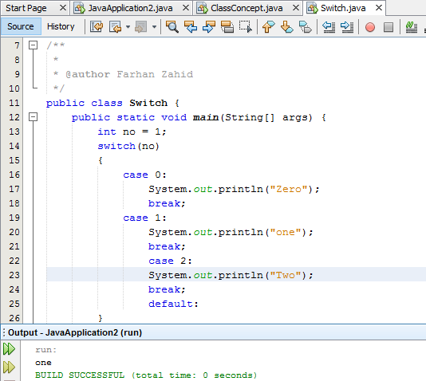

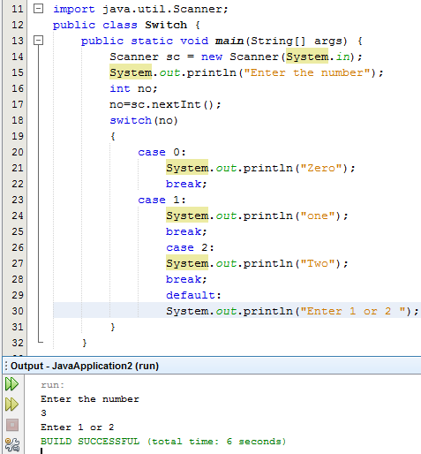**Charter lowercase uppercase using charat** 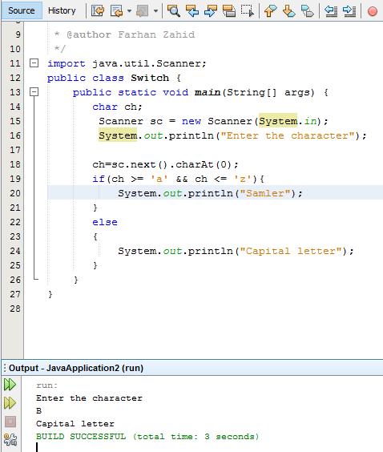

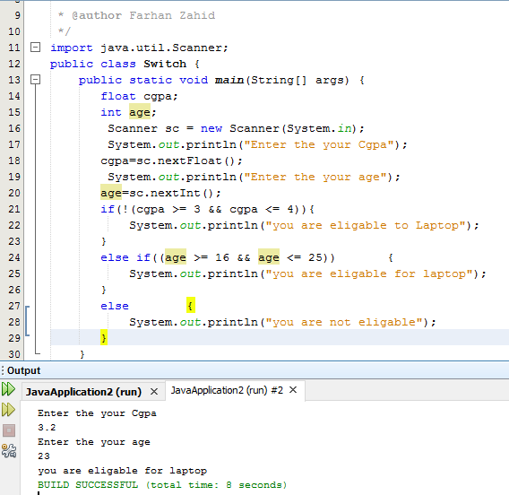

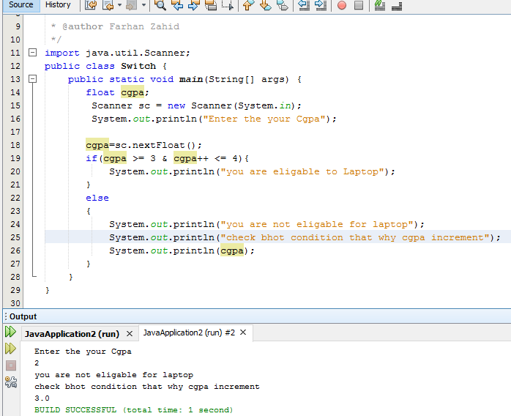

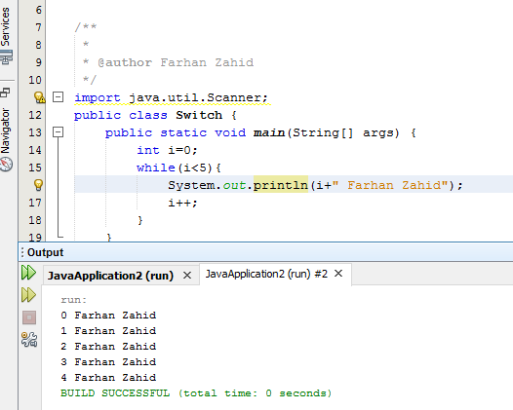

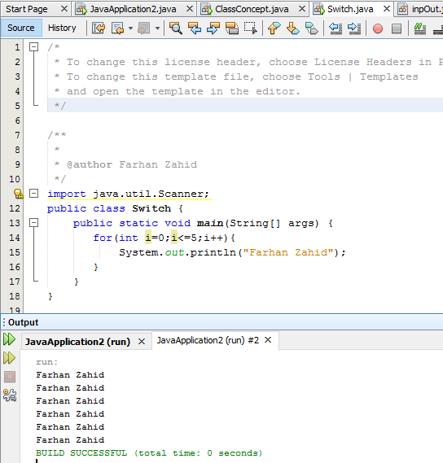

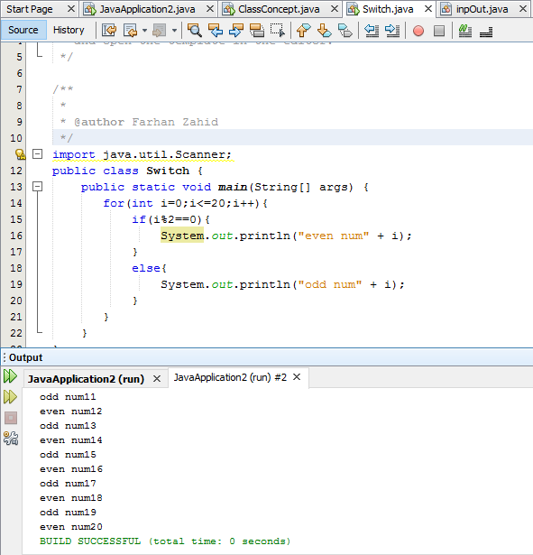

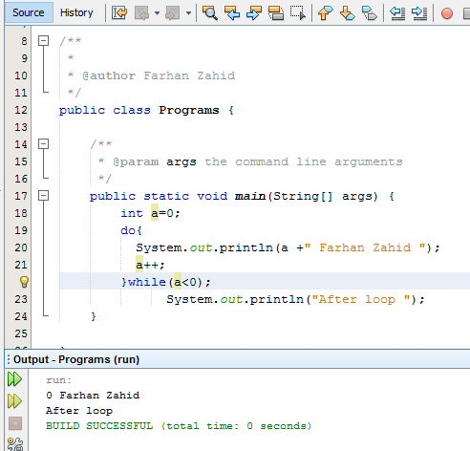

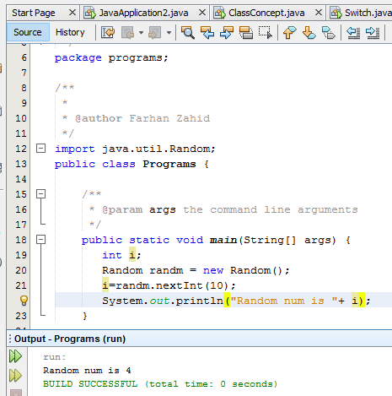

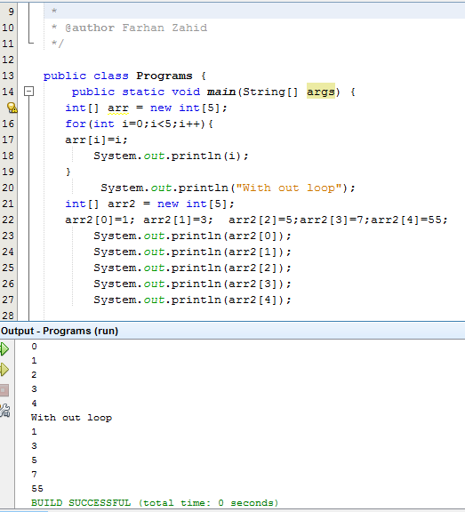

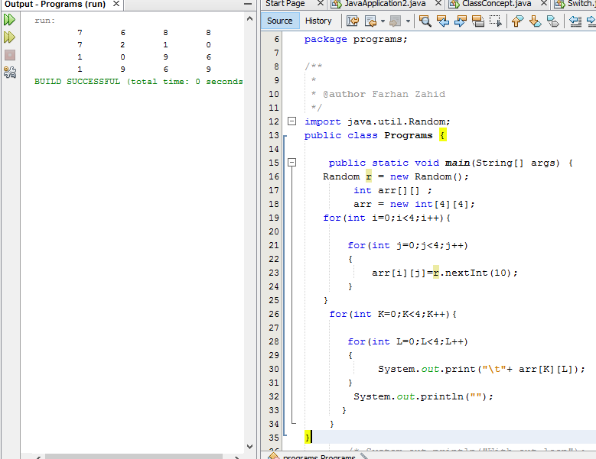

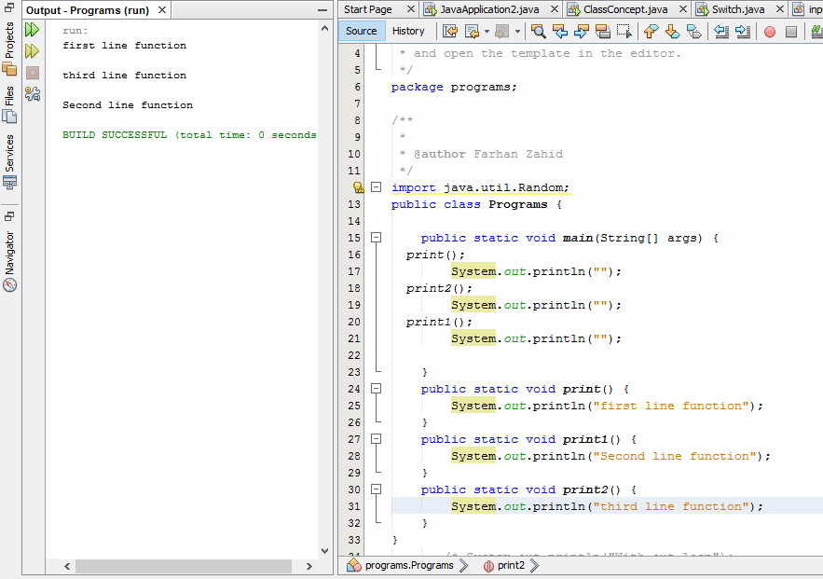

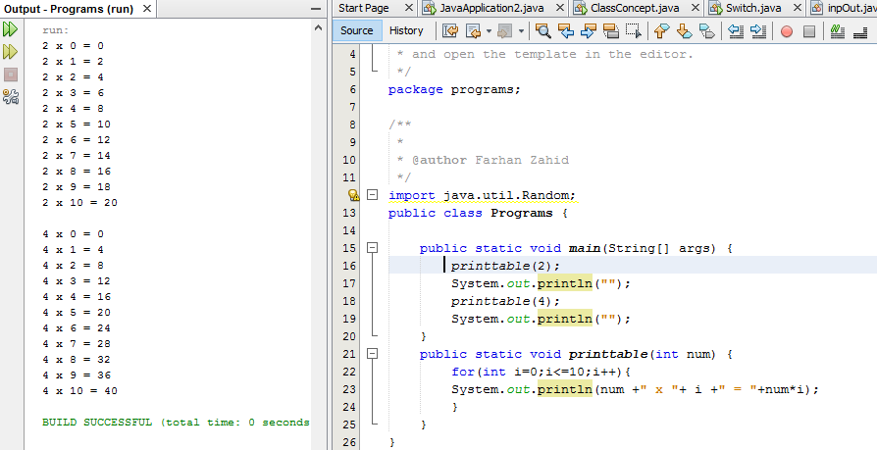

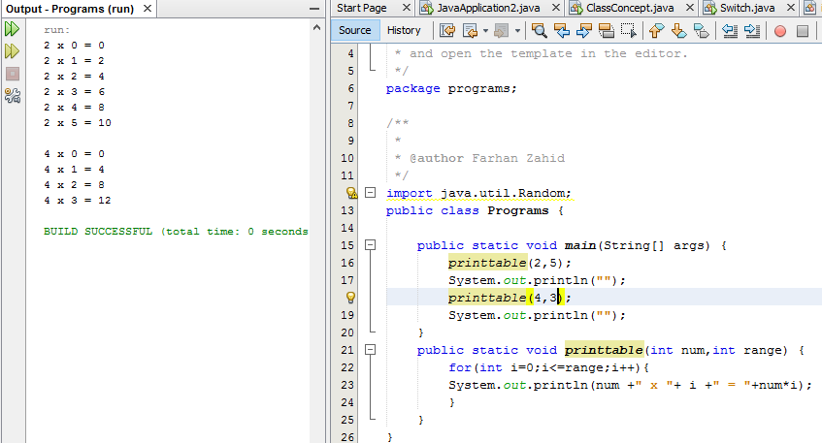

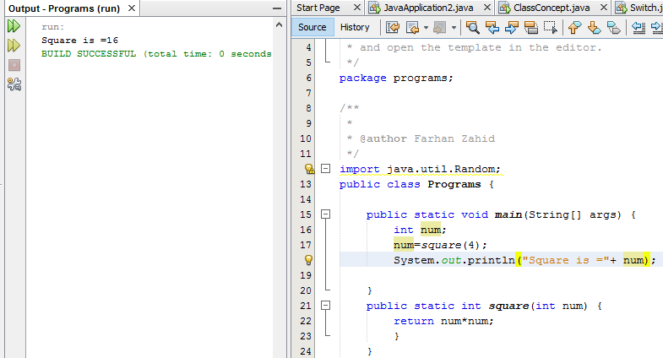

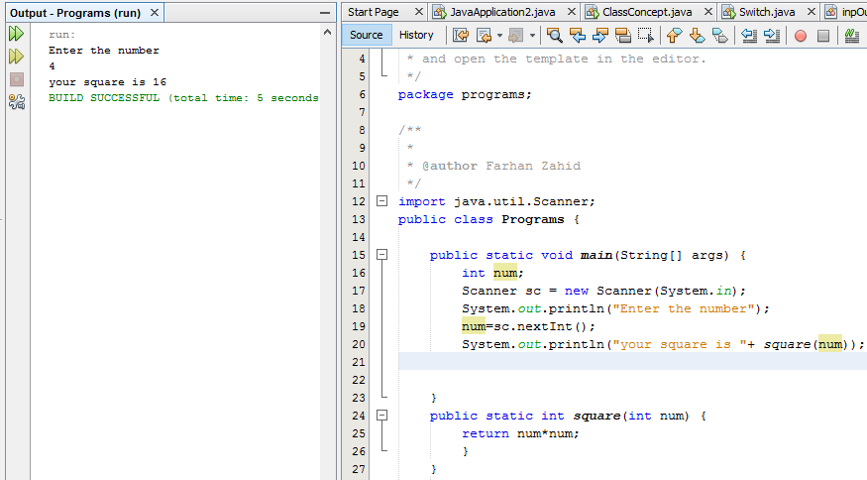

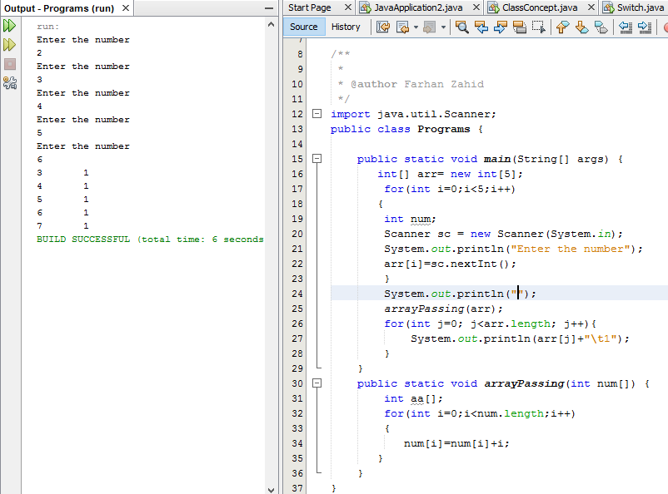

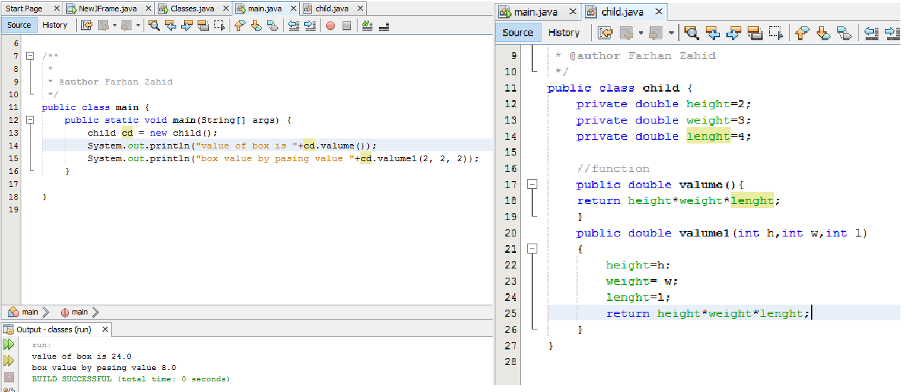

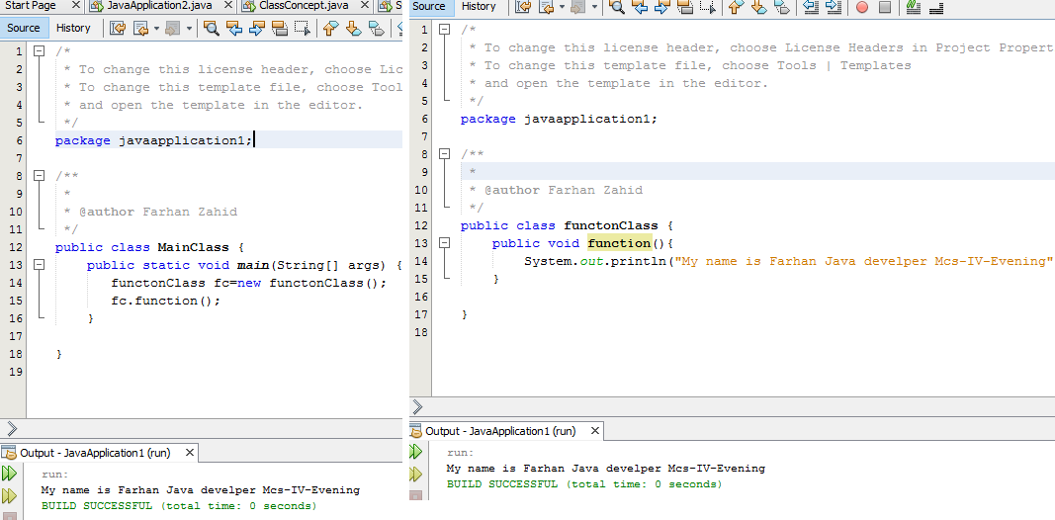

**Main class**

**Constructor overloading**

**public class main {**

**public static void main(String[] args) {**

**child ch = new child();**

**System.out.println("value of box is "+ch.fun());**

**child ch1 = new child(5,2,3);**

**System.out.println("parmeter "+ch1.fun());**

**}**

**}**

**Class box**

**public class child {**

**private double height;**

**private double weight;**

**private double lenght;**

**public child()**

**{**

**height=0;**

**weight=0;**

**lenght=0;**

**}**

**public child(int h,int w,int l)**

**{**

**this.height=h;**

**this.weight= w;**

**this.lenght=l;**

**}**

**//function**

**public double fun(){**

**return height+weight+lenght;**

**}}**

**Inheritance**

**Main class**

**package inheritence;**

**public class Inheritence {**

**public static void main(String[] args) {**

**car c = new car();**

**c.showdata();**

**// TODO code application logic here**

**}**

**}**

**// Vehicle class**

**package inheritence;**

**public class vehicle {**

**public String model;**

**public String year;**

**}**

**Car class**

**package inheritence;**

**/\***

**\* To change this license header, choose License Headers in Project Properties.**

**\* To change this template file, choose Tools | Templates**

**\* and open the template in the editor.**

**\*/**

**/\*\***

**\***

**\* @author Farhan Zahid**

**\*/**

**public class car extends vehicle {**

**public String carName;**

**public void showdata()**

**{**

**carName= "landcuriser";**

**model = "2017lc";**

**year="2017";**

**System.out.println("Car name = "+carName);**

**System.out.println("Car model = "+model);**

**System.out.println("Car year = "+year);**

**}**

**}**

**Super constructor**

**package inheritence;**

**public class Inheritence {**

**public static void main(String[] args) {**

**car c = new car("alto","22222","2015");**

**c.showdata();**

**// TODO code application logic here**

**}**

**}**

**Class vehicle**

**package inheritence;**

**public class vehicle {**

**public String model;**

**public String year;**

**public vehicle(String model, String year)**

**{**

**this.model=model;**

**this.year=year;**

**}**

**}**

**Car class**

**package inheritence;**

**public class car extends vehicle {**

**public String carName;**

**public car(String carName, String model, String year) {**

**super(model, year);**

**this.carName = carName;**

**}**

**public void showdata() {**

**System.out.println("Car name = " + carName);**

**System.out.println("Car model = " + model);**

**System.out.println("Car year = " + year);**

**}**

**}**

**Assigment question**

**1package q1;**

**public class Q1 {**

**/\*\***

**\* @param args the command line arguments**

**\*/**

**public static void main(String[] args) {**

**// TODO code application logic here**

**NewClass e = new NewClass();**

**if (e.booleanisEven(10)) {**

**System.out.println("10 is even.");**

**}**

**if (e.booleanisEven(9)) {**

**System.out.println("9 is even.");**

**}**

**if (e.booleanisEven(8)) {**

**System.out.println("8 is even.");**

**}}}**

**Class**

**package q1;**

**public class NewClass {**

**public boolean booleanisEven(int x)**

**{**

**if ((x % 2) == 0) {**

**return true;**

**}**

**else**

**{**

**return false;**

**}**

**}**

**}**

**2**

**public class Q2 {**

**/\*\***

**\* @param args the command line arguments**

**\*/**

**public static void main(String[] args) {**

**// TODO code application logic here**

**Person p = null;**

**try {**

**p.talk();**

**} catch (NullPointerException e) {**

**System.out.print("There is a NullPointerException.");**

**} catch (Exception e) {**

**System.out.print("There is an Exception.");**

**}**

**System.out.print("Everything went fine.");**

**}**

**}**

**Class**

**public class Person {**

**public void talk(){**

**}**

**}**

**Output**

**There is a NullPointerException.Everything went fine**

**3**

**public static void main(String[] args) {**

**int i = 0, j = 5;**

**for (; (i < 3) && (j++ < 10); i++) {**

**System.out.print(" " + i + " " + j);**

**}**

**System.out.print(" " + i + " " + j);**

**}**

**}**

**Output**

**0 6 1 7 2 8 3 8BUILD SUCCESSFUL (total time: 1 second)**

**4.**

**public class Q3 {**

**/\*\***

**\* @param args the command line arguments**

**\*/**

**public static void main(String[] args) {**

**int x = 0;**

**Person p = new Person();**

**new Test().doIt(x, p);**

**System.out.println(x + " " + p.number);**

**}**

**}**

**1.class**

**public class Person {**

**public int number;**

**}**

**2 class**

**public class Test {**

**public void doIt(int i, Person p) {**

**i = 5;**

**p.number = 8;**

**}**

**}**

**Question 7**

**public class Q7 {**

**public static void main(String[] args) {**

**// TODO code application logic hereSubCLass**

**SubCLass obj = new SubCLass();**

**obj.display();**

**}**

**}**

**public class Q6 {**

**public static void main(String[] args) {**

**// TODO code application logic here**

**int[] a = new int[3];**

**a[1] = 50;**

**Object o = a;**

**int[] b = (int[]) o;**

**b[1] = 100;**

**System.out.println(a[1]);**

**((int[]) o)[1] = 500;**

**System.out.println(a[1]);**

**}**

**Output**

**run:**

**100**

**500**

**BUILD SUCCESSFUL (total time: 0 seconds)**

**Q7**

**public class Q7 {**

**/\*\***

**\* @param args the command line arguments**

**\*/**

**public static void main(String[] args) {**

**// TODO code application logic hereSubCLass**

**SubCLass obj = new SubCLass();**

**obj.display();**

**}**

**}**

**Class 1**

**public class SubCLass extends Inherit_Single {**

**SubCLass()**

**{**

**str = str.concat("World !!!");**

**}**

**void display() {**

**System.out.println(str);}**

**}**

**Class 2**

**public class Inherit_Single {**

**protected String str;**

**Inherit_Single() {**

**str = "Java ";**

**}**

**}**

**Output**

**Java World !!!**

**BUILD SUCCESSFUL (total time: 0 seconds)**

**Q9**

**public static void main(String[] args) {**

**// TODO code application logic here**

**equality obj = new equality();**

**obj.x = 5;**

**obj.y = 5;**

**System.out.println(obj.isequal());**

**}**

**}**

**Class**

**public class equality {**

**int x;**

**int y;**

**boolean isequal() {**

**return (x == y);**

**}**

**}**

**output**

**run:**

**true**

**BUILD SUCCESSFUL (total time: 0 seconds)**

**Q10**

**public class Q10 {**

**public static void main(String[] args) {**

**// TODO code application logic here**

**area obj = new area();**

**obj.area(5, 6);**

**System.out.println(obj.length + " " + obj.width);**

**}**

**}**

**Class**

**public class area {**

**int width;**

**int length;**

**int area;**

**void area(int width, int length) {**

**this.width = width;**

**this.length = length;**

**}**

**}**

**Output**

**6 5**

**BUILD SUCCESSFUL (total time: 0 seconds)**

**Q11**

**public class Q11 {**

**public static void main(String[] args) {**

**// TODO code application logic here**

**double a, b;**

**a = 3.0;**

**b = 4.0;**

**double c = Math.sqrt(a * a + b * b);**

**System.out.println(c);**

**}**

**}**

**output**

**5.0**

**BUILD SUCCESSFUL (total time: 0 seconds)**

**Q12**

**public class Q12 {**

**/\*\***

**\* @param args the command line arguments**

**\*/**

**public static void main(String[] args) {**

**// TODO code application logic here**

**int arr[][] = new int[3][];**

**arr[0] = new int[1];**

**arr[1] = new int[2];**

**arr[2] = new int[3];**

**int sum = 0;**

**for (int i = 0; i < 3; ++i) {**

**for (int j = 0; j < i + 1; ++j) {**

**arr[i][j] = j + 1;**

**}**

**}**

**for (int i = 0; i < 3; ++i) {**

**for (int j = 0; j < i + 1; ++j) {**

**sum+=arr[i][j];**

**System.out.println("sum is "+sum);**

**}**

**}**

**System.out.print(sum);**

**}**

**}**

**Output**

**run:**

**sum is 1**

**sum is 2**

**sum is 4**

**sum is 5**

**sum is 7**

**sum is 10**

**10BUILD SUCCESSFUL (total time: 0 seconds)**

**Q13**

**public static void main(String[] args) {**

**// TODO code application logic here**

**access obj1 = new access();**

**access obj2 = new access();**

**obj1.x = 0;**

**obj1.y = 0;**

**obj1.cal(1, 2);**

**obj2.x = 0;**

**obj2.cal(2, 3);**

**System.out.println(obj1.x + " " + obj2.y);**

**}**

**}.**

**Class**

**public class access {**

**public int x;**

**static int y;**

**void cal(int a, int b) {**

**x += a;**

**y += b;**

**}**

**}**

**output**

**1 5**

**BUILD SUCCESSFUL (total time: 0 seconds)**

**Q14**

**public static void main(String[] args) {**

**// TODO code application logic here**

**// TODO code application logic here**

**access obj1 = new access();**

**access obj2 = new access();**

**obj1.x = 0;**

**obj1.increment();**

**obj2.increment();**

**System.out.println(obj1.x + " " + obj2.x);**

**}**

**}**

**Clas s**

**public class access {**

**static int x;**

**void increment() {**

**x++;**

**}**

**}**

**output**

**2 2**

**BUILD SUCCESSFUL (total time: 0 seconds)**

**Q15**

**public static void main(String[] args) {**

**// TODO code application logic here**

**B obj = new B();**

**obj.i = 1;**

**obj.j = 2;**

**obj.display();**

**}**

**}**

**CLASS1**

**public class A {**

**int i;**

**void display() {**

**System.out.println(i);**

**}**

**}**

**CLASS 2**

**public class B extends A {**

**int j;**

**void display() {**

**System.out.println(j);**

**}**

**}**

**Q16**

**public static void main(String[] args) {**

**// TODO code application logic here**

**displayA arr1 = new displayA();**

**displayB arr2 = new displayB();**

**arr1.x = 0;**

**arr2.x = 0;**

**arr1.cal(2);**

**arr2.cal(2);**

**System.out.print(arr1.x + " " + arr2.x);**

**}**

**}**

**Class**

**public class displayA {**

**int x;**

**public void cal(int item) {**

**x = item * item;**

**}**

**}**

**Class 2**

**public class displayB {**

**int x;**

**public void cal(int item) {**

**x = item / item;**

**}**

**}**

**Output**

**4 1**

**BUILD SUCCESSFUL (total time: 0 seconds)**

**Q17**

**public static void main(String[] args) {**

**// TODO code application logic here**

**display[] arr = new display[3];**

**for (int i = 0; i < 3; i++) {**

**arr[i] = new display();**

**}**

**arr[0].x = 0;**

**arr[1].x = 1;**

**arr[2].x = 2;**

**for (int i = 0; i < 3; ++i) {**

**arr[i].show();**

**}**

**}**

**}**

**CLASS**

**public class display {**

**int x;**

**void show() {**

**if (x > 1) {**

**System.out.print(x + " ");**

**}**

**}**

**}**

**OUTPUT**

**run:**

**2**

**BUILD SUCCESSFUL (total time: 0 seconds)**